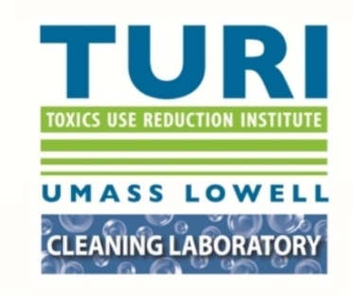

Toxics Use Reduction Institute’s Cleaning Lab
UMass Lowell
The Offices at Boott Mills West
126 John Street, Suite 14 (2nd Floor)
Lowell, MA 01852

TURI SURFACE SOLUTIONS LABORATORY
EVALUATION SUMMARY
SCL #: 18-429-1-2
Date Run: 3/28/18
Experimenters: Green; Rainaud; Wilson; Patel
Substrates: Glass; Chrome;
Contaminants: SSL Soil 2 Glass
Cleaning Methods: Manual – Straight Line Washability Unit (SLW)
Analytical Methods: Gravimetric, visual observations
Purpose: To evaluate the effectiveness of a glass cleaner on the removal of SSL Soil 2 Glass from several substrates.

Experimental Procedure:
Preweighed Glass, Chrome, coupons were coated with SSL Soil 2 (Glass soap scum: Water 51.5%, Hair gel 25.6%, Toothpaste 10.4%, Shaving cream 5.3%, Hair spray 3.7% and Spray deodorant 3.5%) using a hand held swab and allowed to dry for 24 hours at room temperature. The contaminated coupons were weighed again to determine the amount of soil added. Three coupons were placed into a Gardner Straight Line Washability unit. A Wypall L60 reinforced wipe was attached to the cleaning sled and soaked with 1 spray of cleaning solutions. One scoop of salt was added to water to make E-Mop cleaner (1 scoop of salt = 3.0516 g), the resulting concentration was 310 ppm. Each coupon was sprayed 1 time with the same cleaning solution. The solution was allowed to penetrate for 30 seconds followed by cleaning in the SLW unit for 5 cycles (~10 seconds). Coupons were left to dry overnight before final weights and efficiencies were recorded.

Cleaners evaluated: Three Main Products Multi-Surface Cleaner

Results:
Cleaner | Substrate | Initial Weight of Cont. | Final Weight of Cont. | % Cont. Removed | Average % Removed | Overall % Removed
Thane Direct E-Mop | Glass | 37.7009 | 0.0015 | 97.65 | 97.73 | 97.82
 |  | 37.7016 | 0.0017 | 98.38
 |  | 37.6323 | 0.0011 | 97.17
 | Chrome | 63.3620 | 0.0001 | 99.85 | 97.90
 |  | 64.2003 | 0.0024 | 96.13
 |  | 64.5190 | 0.0018 | 97.73
Windex | Glass | 37.5465 | 0.0013 | 98.01 | 98.04 | 96.67
 |  | 37.7371 | 0.0015 | 97.63
 |  | 37.4404 | 0.0010 | 98.48
 | Chrome | 63.7205 | 0.0039 | 94.14 | 95.33
 |  | 63.0794 | 0.0024 | 96.05
 |  | 63.9050 | 0.0027 | 95.81

Summary: Concentration of solution: 200 ppm
Substrates: Glass; Chrome;
Contaminants: SSL Soil 2 Glass
Company Name | Product Name | Average % Removal | Effective
Thane Direct | E-Mop | 97.82 | YES
 | Windex | 96.67 | YES

Conclusion:
E-mop and Windex were effective at removing SSL Soil 2 Glass from glass and Chrome surfaces. The overall average removal rate was 97.815% and 96.67%

